String Class Constructor

1. Constructors:
   1. new String(): creates empty string objec.
   2. new String(“String_Literal”): Creates a string object for a given String Literal.
   3. new String(StringBuffer): Creates an equivalent String object for StringBuffer.
   4. new String(char[]): Creates an equivalent String object for passed char array.

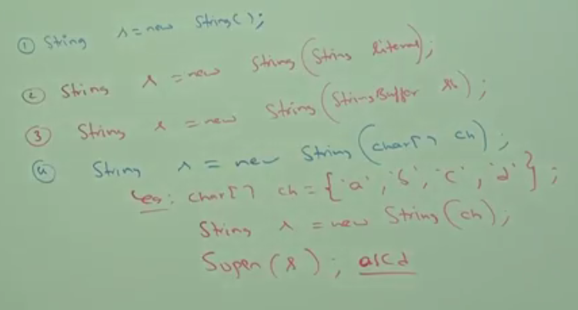

* 1. new String(byte[]): where byte is numeric representation for ASCII Code.

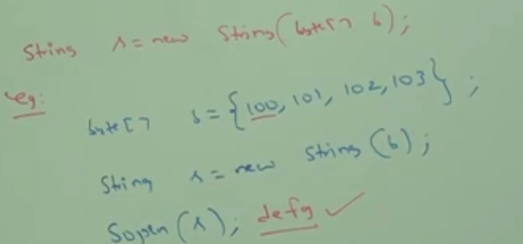



1. d

String Class Methods

1. 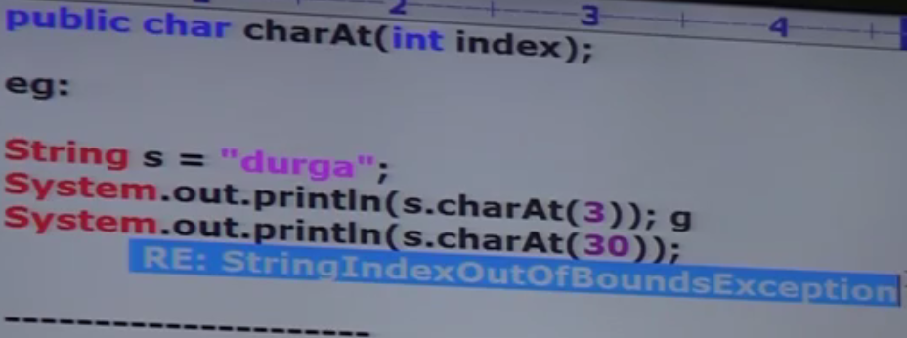
2. 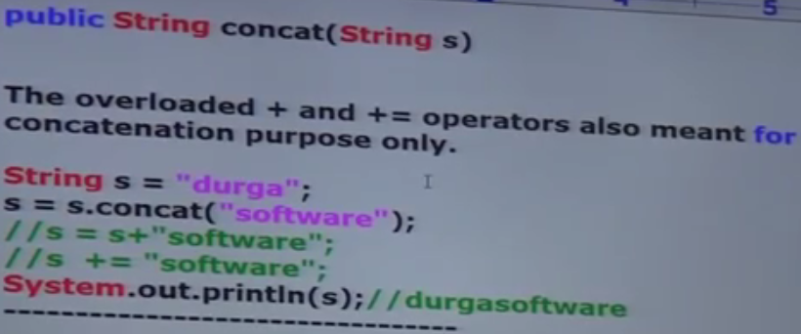
3. 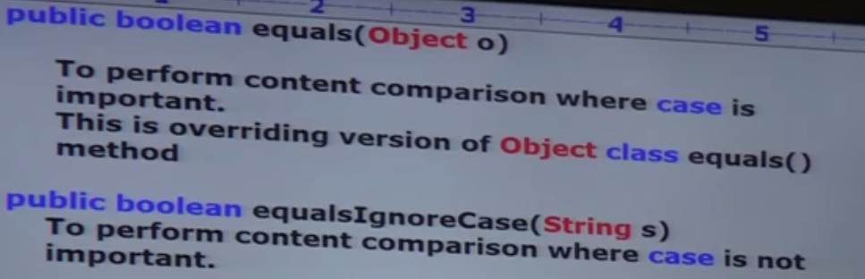
4. 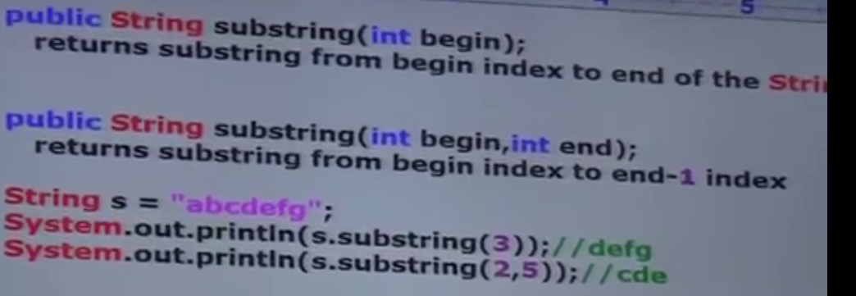
5. 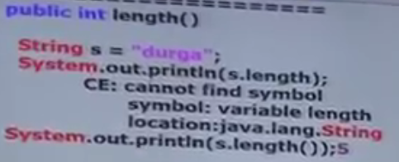
6. 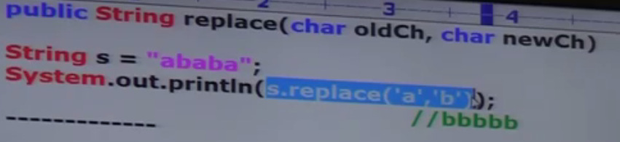
7. 
8. 
9. 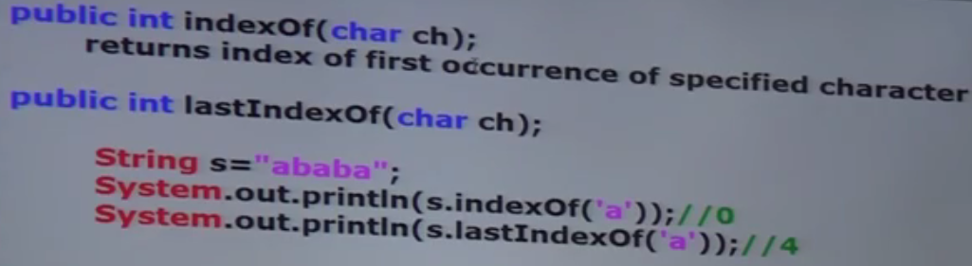
10. d

String runtime method

1. *** Because of runtime operation, if there is change in the content, then with those changes a new object will be created on the heap otherwise existing object will be reused.  
   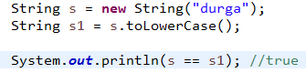  
   NOTE: If we are performing any runtime operation on String Constant , but there is no change, even then String Constant/literal will be reused.  
     
   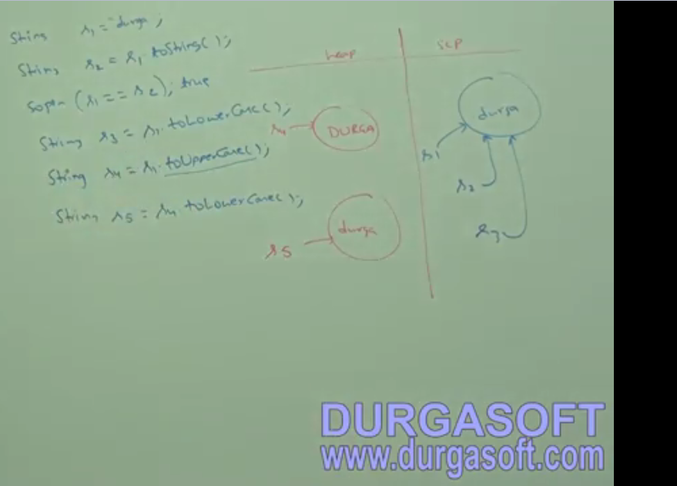

when s4.toLowerCase(), a new String object on heap will be created as changes to s4 content were made.

1. **immutability** : Once we create an object, we can’t perform any changes to the object. If we are trying to perform any change and if there is change in the content, then with those changes a new object will be created.  
   if there is no change in the content then existing object will be reused. This behavior is nothing but **immutability**.  
     
   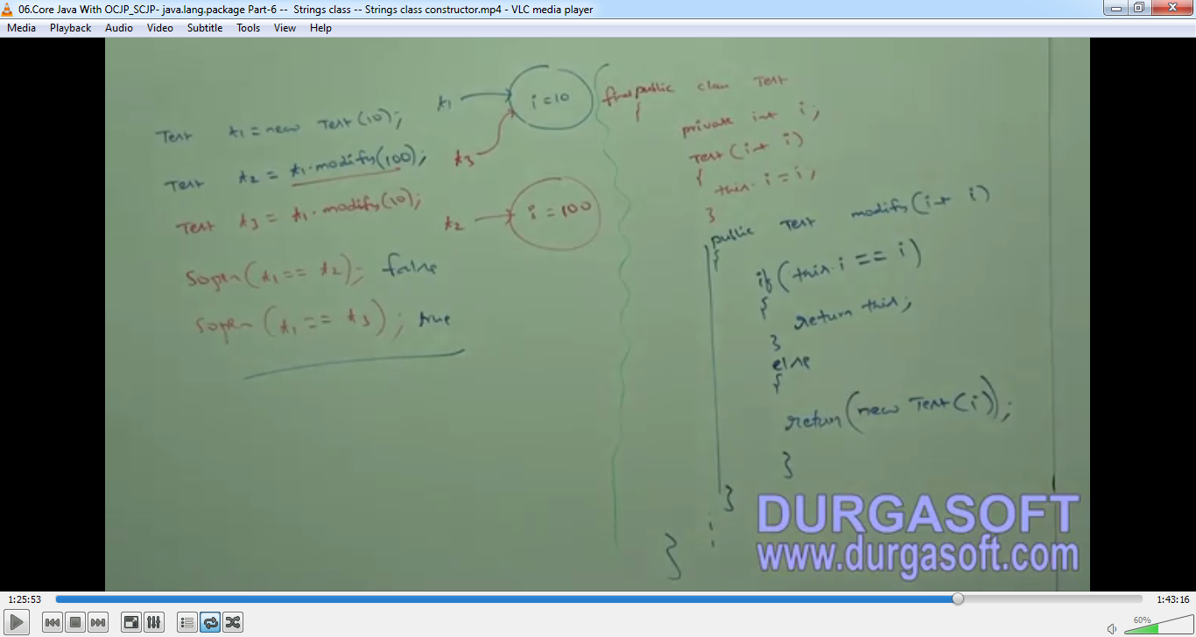
2. d

final vs immutability

1. Applicable for variables but not for objects whereas immutability is applicable for objects but not for variables.
2. By declaring a reference variable as final, we don’t get any immutability nature even though reference variable is final, we can perform any kinds of change on the object but we can’t perform reassignment for that variable.
3. Hence final and immutability both are different concepts.
4. Example:  
     
   Example01:  
   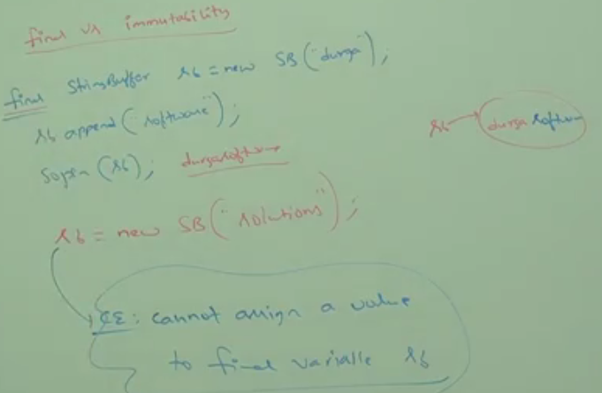

**Even though s is final, we can change the content of the object to which final s variable is pointing**